Run for your life Temple escape.

This game is a speed running game. In this game when the player starts the game his character will start running on a long narrow space. The player should try to reach the end of the track. As the player run there will be obstacles everywhere. Players should try to avoid the obstacles to reach the end.

Back story.

You have found your way into the temple and claimed the treasure but you have set off the traps that guard it. Now it’s time to run for your life.

Gameplay.

This is a 3rd person speed running game. The camera will be right behind the play following as he runs through the track. Plays should try to avoid obstacles as they run. If they run into an obstacle they will die and be sent back to the beginning.

Basic controls

D for turn right.

A for turn left.

Space for jump

S for duck.

Scene layout.

It is just a very long narrow hall way that the player runs in. The hall way will turn left or right. The hallway will contain traps and obstacles that the player has to avoid.

Inspiration and example of the game.

Temple run. 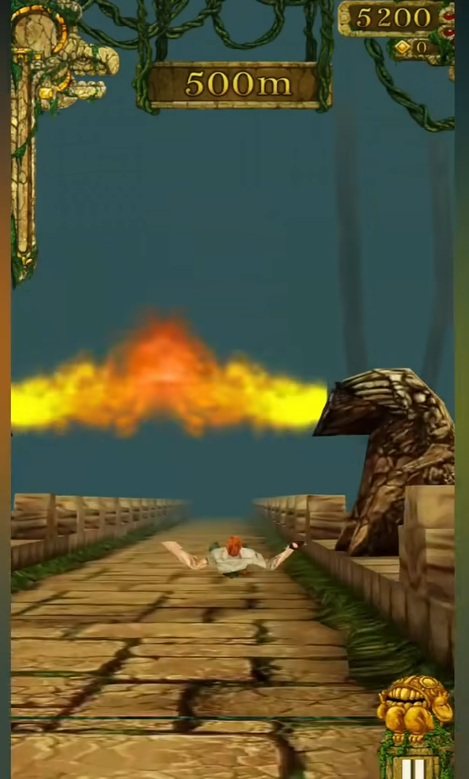

Targeted audience.

For player who like speed running games.